
National Forensic Sciences University, Gandhinagar
School of Cyber Security and Digital Forensics

Course Name : MSc Cyber Security
Batch : 2025-27
Semester : 1
Subject Code : CTMSCS SI P3
Subject Name: Web Application Security
Assignment Title: TA-2 Assignment

Student Name: Aastha Thakker
Enrollment No.: 250103002004

Date of Submission : 30th November, 2025
Submitted To : Dr. Jay Teraiya

Vulnerabilities

SQL Injection
Description: SQL Injection (SQLi) is a web application vulnerability where untrusted user input becomes part of a database query. When the application fails to validate or properly handle input, attackers can alter SQL queries, allowing them to read sensitive data, modify records, delete entries, or in severe cases take full control of the database.
Platform: DVWA
Tools: N/A
Steps:
- Open DVWA/Security Shepherd → SQL Injection module.
- Enter payload like 1' OR '1'='1 to dump all users.
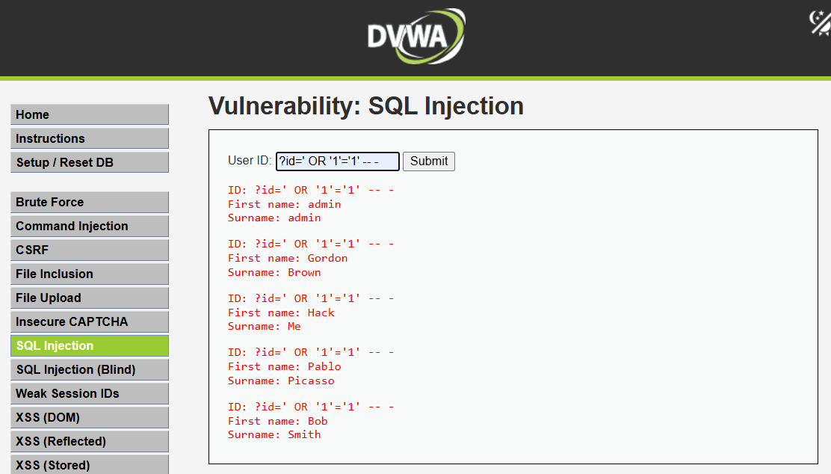
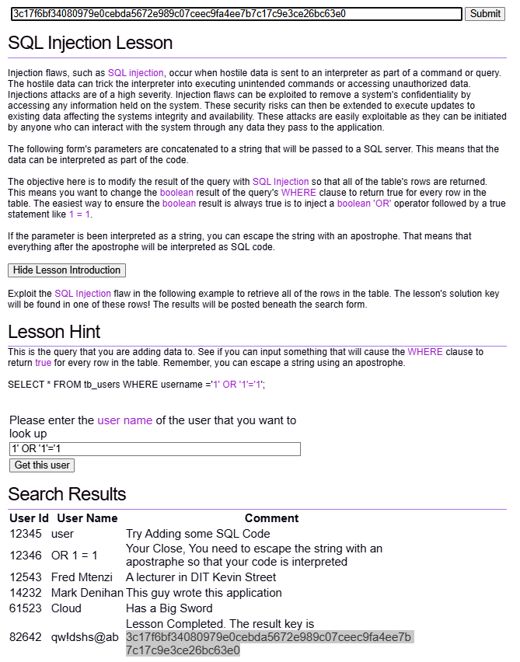
Mitigation:
- Validate and sanitize all inputs
- Use parameterized queries or prepared statements
- Restrict detailed database error messages
- Apply proper escaping to user-supplied data

2. Broken Authentication
Description: Broken authentication refers to weaknesses in the way an application manages login, session handling, or identity verification, allowing attackers to impersonate legitimate users. When authentication mechanisms are poorly designed—such as weak passwords, predictable session IDs, missing multi-factor checks, or improper session expiration—an attacker can hijack accounts, access sensitive data, or take over user sessions
Tool Used: BurpSuite
Platform: Security Shepherd
Steps:
- Open security shepherd and go to Broken authentication and session management. Click on the complete the lesson button this will generate the request capture the request with burp suite. Send that request to repeater.
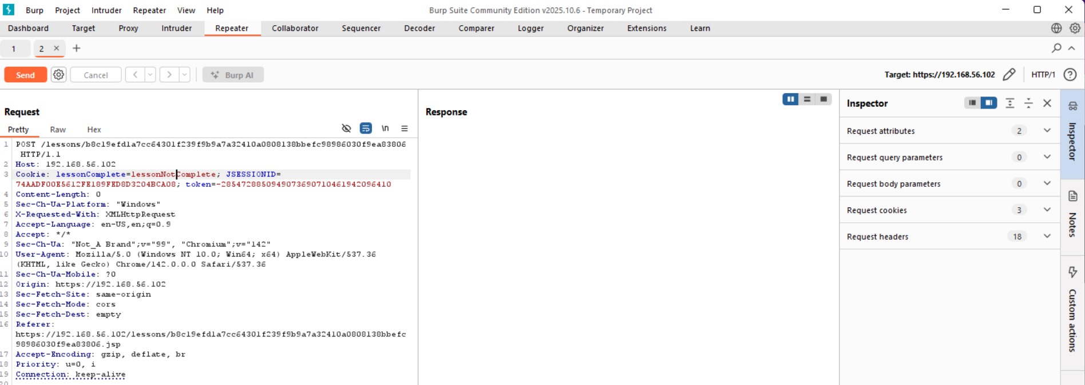
- Change ‘lessonnotcompleted’ to ‘lessoncompleted’.
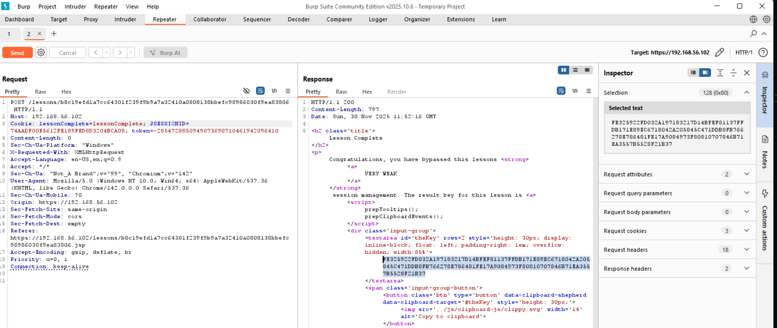
- Submit the key.
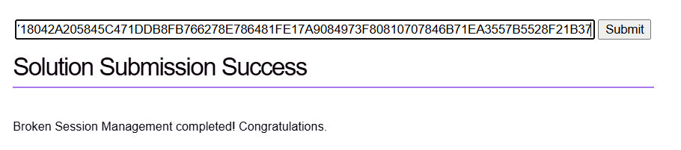
Mitigation:
- Enforce strong password and MFA requirements
- Implement rate limiting and lockout policies
- Use secure, unpredictable session IDs
- Ensure proper session timeout and invalidation

Sensitive Data Exposure
Description: Sensitive data exposure occurs when confidential information—such as personal details, financial records, passwords, tokens, or health data—is not properly protected during storage, processing, or transmission. This happens due to weak encryption, insecure data transfer channels, misconfigured servers, or storing more data than necessary. When such information is exposed, attackers can misuse it for identity theft, financial fraud, or unauthorized system access. It basically means critical data is accessible to people who should never see it because the application failed to safeguard it properly.
Tool Used: BurpSuite
Platform: PortSwigger - Information disclosure in error messages.
Steps:
- Open PortSwigger and click the lab named ‘Information Disclosure in error messages.
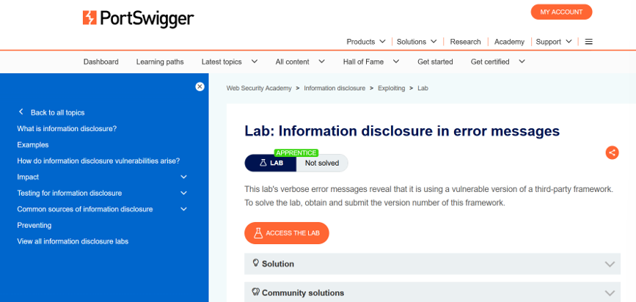
- Now open the lab and click on the anything in the web page this will generate the request and capture that request with burpsuite.
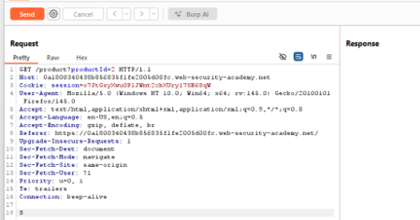
- Now modify the request parameter product id from the integer to any non-integer value and send it.
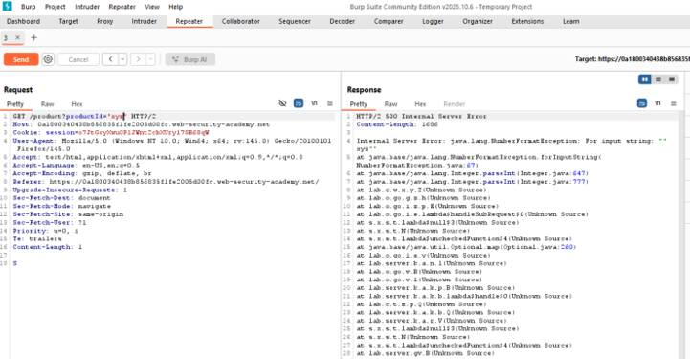
- It will give the value of an server that is critical detail that can be used aagainst the webapplication we have to paste the vulnerable framework version information in order to complete the lab so we can verify the attack.
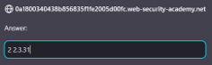
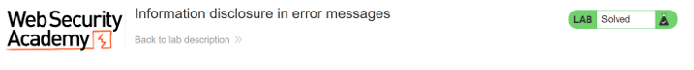
Mitigation:
- Encrypt sensitive data at rest and in transit
- Use strong, up-to-date cryptographic algorithms
- Avoid storing unnecessary sensitive information
- Secure keys, credentials, and configuration files

XML External Entities (XXE)
Description: XXE is a security flaw that occurs when an application processes XML input using a parser that allows external entities. Attackers can inject malicious XML content that forces the parser to load external files, access internal server resources, or send sensitive data to an attacker-controlled location. In severe cases, XXE can even lead to server-side request forgery (SSRF), file reading, or complete system compromise. In simple terms, XXE happens when an application trusts XML input too much and unintentionally exposes internal files or network details.
Tool Used: BurpSuite
Platform: PortSwigger - Exploiting XXE using external entities to retrieve files
Steps:
- Open portswigger labs and go to the XXE injection section. Open lab and click on any product to generate the request and capture using burpsuite. 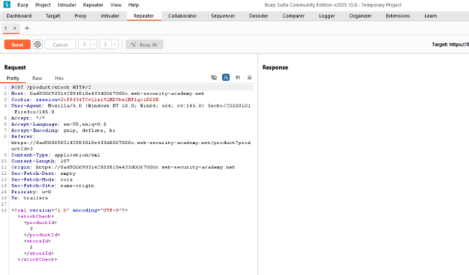
- Now make changes shown below and send the request.
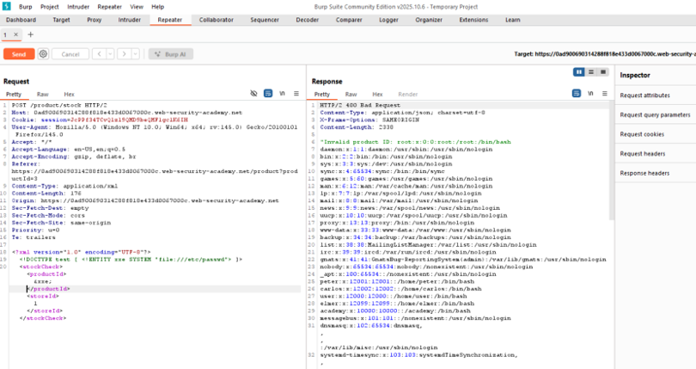
- Retrieve the content of /etc/passwd folder and check lab status.
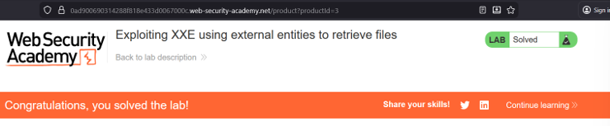
Mitigation:
- Disable external entity and DTD processing
- Use secure, updated XML parsers
- Validate and sanitize XML input
- Shift to safer data formats like JSON where possible
- Perform XSD validation.

Broken Access Control
Description: Broken access control occurs when an application fails to correctly enforce who is allowed to do what. This means users can access data or perform actions that should be restricted, such as viewing someone else’s records, modifying admin-only settings, or bypassing authorization checks through direct URL manipulation or API calls. These issues arise from missing permission checks, insecure role handling, or relying only on client-side controls.
Tool Used: N/A
Platform: PortSwigger - Unprotected admin functionality.
Steps:
- Open the unprotected admin functionality lab.
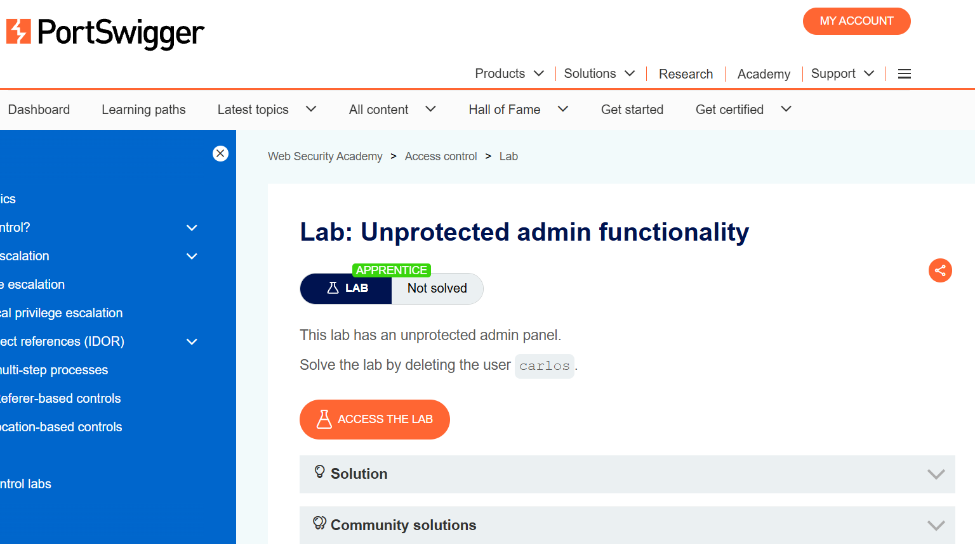
- Now open the lab and in the URL section add the robots.txt and click enter.
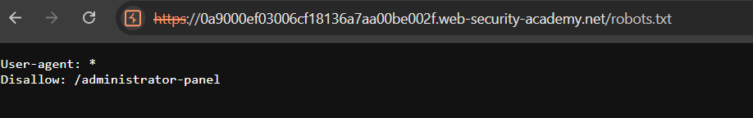
- Use this information and add in URL.
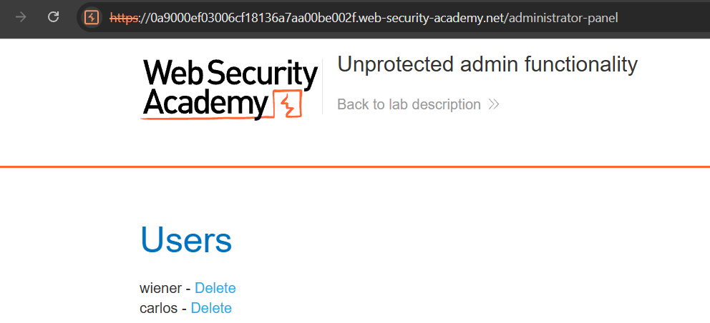
- As per the lab, delete carlos user. And the lab is solved.
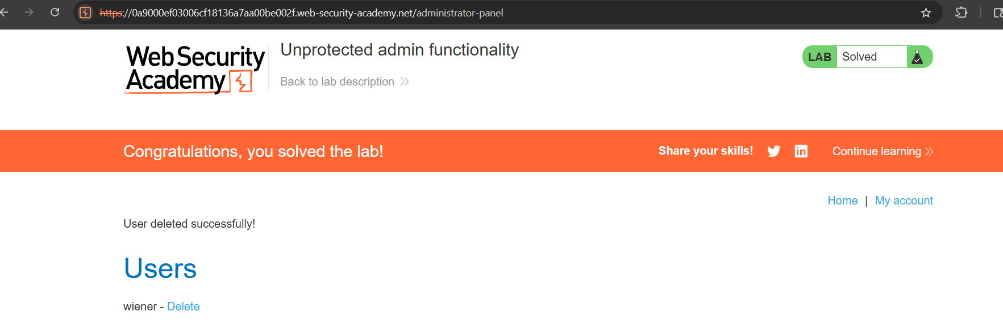
Mitigation:
- Enforce server-side authorization checks for every request
- Use proper role-based or attribute-based access controls
- Disable direct object access without validation
- Deny-by-default for sensitive endpoints

Security Misconfiguration
Description: Security misconfiguration happens when systems, servers, applications, or network components are set up with unsafe default settings, unnecessary features, weak permissions, or incomplete security controls. This can include exposed admin panels, verbose error messages, outdated software, open ports, or misconfigured cloud storage buckets. Because of these gaps, attackers can easily discover vulnerabilities, access sensitive information, or take control of the system.
Tool Used: N/A
Platform: SecurityShepherd
Steps:
- Open SecurityShepherd and go to security misconfiguration lesson.
- In that just try random and common username and password. I used ‘admin’ as username and ‘password’ as password. It got successful and we got the key.
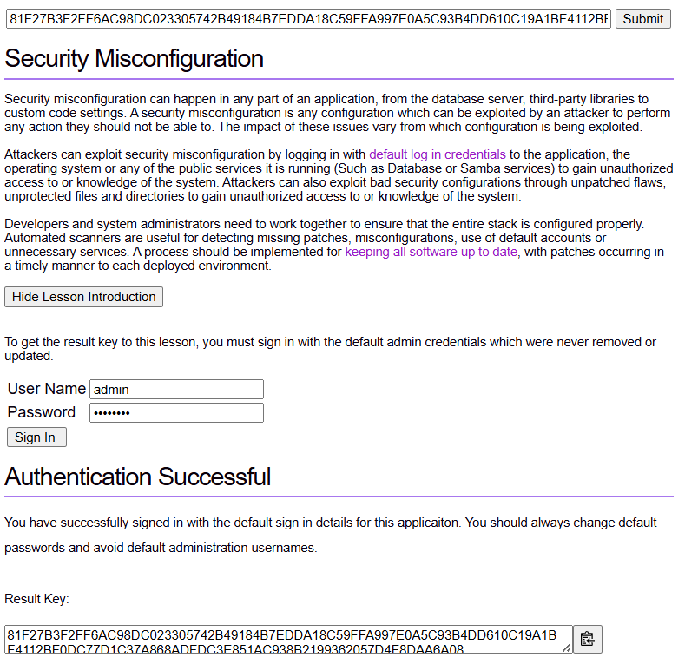
Mitigation:
- Disable unused services, ports, and features
- Use hardened configurations and remove default credentials
- Regularly patch and update all components
- Automate configuration checks and audits

Cross Site Scripting (XSS)
Description: XSS is a web vulnerability where attackers inject malicious scripts, usually JavaScript, into webpages viewed by other users. When the site fails to properly handle untrusted input, the attacker’s script runs in the victim’s browser and can steal cookies, capture keystrokes, redirect users, or manipulate page content.
Tool Used: N/A
Platform: SecurityShepherd
Steps:
- Open security shepherd and go to cross site scripting lesson.
- In this page, we are provided with the input box which is vulnerable to attack. In that we will add JavaScript code “<script>alert(‘XSS was found here’)</script>” and hit ENTER.
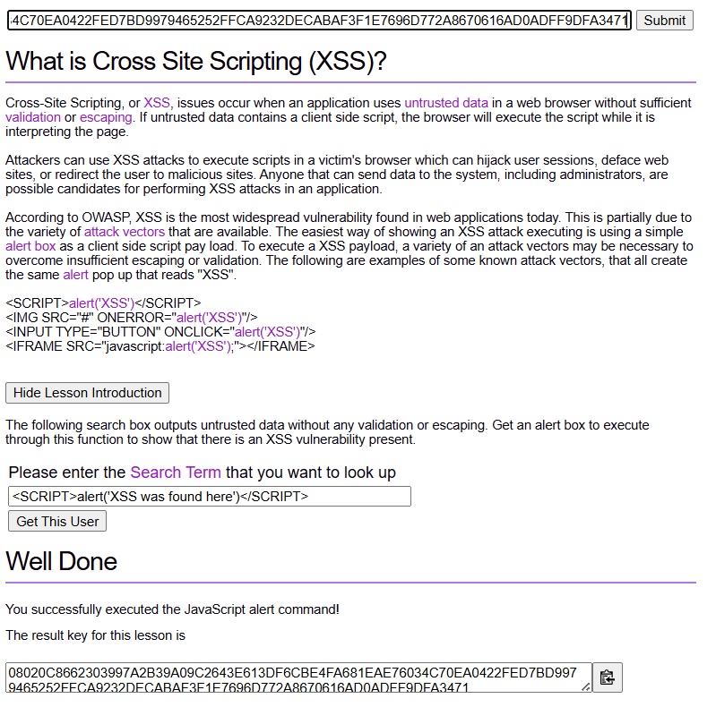
- The pop up will be generated along with the message we sent. After that we will have a solution key to complete the lesson.
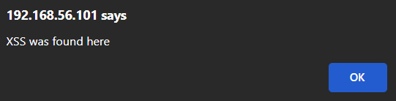
Mitigation:
- Escape and encode untrusted output
- Use input validation and sanitization
- Implement Content Security Policy (CSP)
- Avoid directly inserting raw user input into HTML/JS

Insecure Deserialization
Description: Insecure deserialization happens when an application accepts serialized data (like objects, tokens, or structured input) from untrusted sources and converts it back into executable objects without proper validation. Attackers exploit this by modifying the serialized data to inject harmful payloads, leading to remote code execution, privilege escalation, logic manipulation, or unexpected application behavior.
Tool Used: BurpSuite
Platform: PortSwigger - Modifying Serialized Object
Steps:
- Open the ‘modifying serialized objects’ lab.
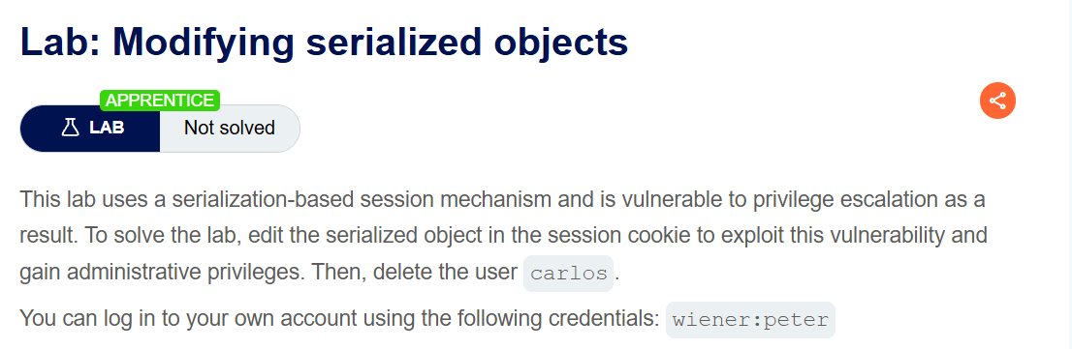
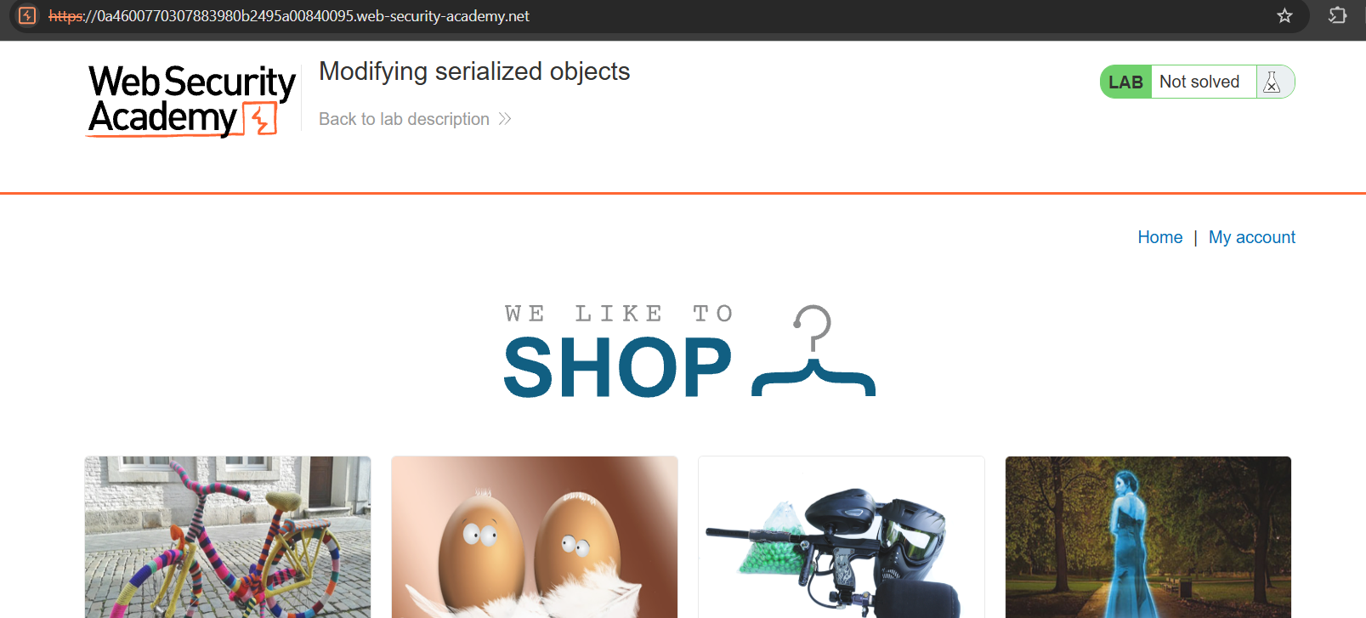
- Now enter your username and password given in the lab description and intercept the request using burpsuite and send it to repeater. To perform the attack we have to change the value of admin from b:0 to b:1 and have to click on apply changes this will encrypt the string.
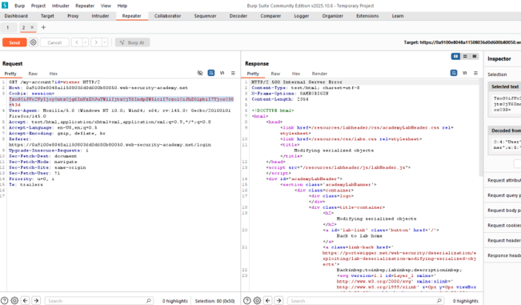
- Copy the string and past that string in the browser and change the value of the cookie to new value and refresh the page.
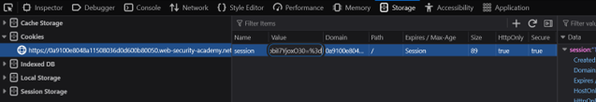
- Now we can see the option of an admin panel that is not available before now we have to click on the admin panel option.
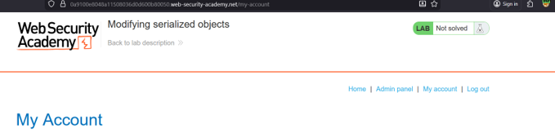
- To complete the lab we have to delete a user to confirm that we have the access of an administrator rights and after deleting the user we can say that we have successfully performed the manipulation of an serialized object.
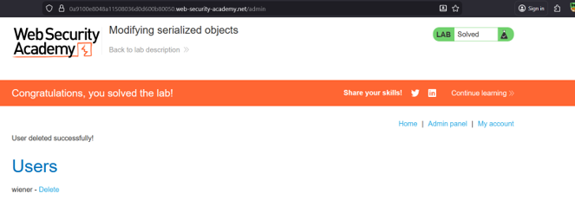

Mitigation:
- Avoid deserializing untrusted or user-controlled data
- Use safe, strict data formats like JSON instead of raw objects
- Implement integrity checks (signing or encryption)
- Enforce strict type validation during deserialization

Using components with known Vulnerabilities
Description: This issue occurs when applications rely on outdated or unpatched software components, such as libraries, frameworks, plugins, or third-party services, that contain publicly known security flaws. Attackers often scan for these weaknesses because they are easy entry points and require no new exploitation techniques. When developers use vulnerable components, the entire application inherits their risks, leading to data breaches, remote code execution, or full system compromise.
Tool Used: ZAP
Platform: DVWA
Steps:
- Start a new session on ZAP. Now go to automated scan. Choose the DVWA target.
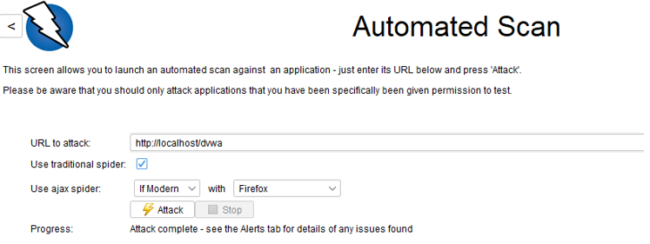
- After completing the scan, you can see all the vulnerabilities present in this application.
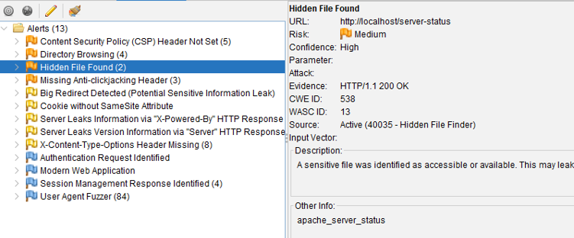
Mitigation:
- Regularly update and patch all libraries, frameworks, and dependencies
- Use software composition analysis (SCA) tools to detect vulnerable components
- Remove unused, outdated, or unsupported packages
- Download components only from trusted and verified sources

Insufficient Logging & Monitoring
Description: This vulnerability occurs when an application does not properly record security-relevant events or fails to monitor those events in real time. Without detailed logs, such as failed logins, suspicious API calls, privilege changes, or access to sensitive data, attackers can perform malicious activities without being detected. Poor monitoring also means alerts are never triggered, investigations become difficult, and incidents stay hidden for long periods.
Tool Used: Wazuh
Steps:
- Wazuh is an open-source SIEM and XDR platform that collects, analyzes, and correlates security events across endpoints for threat detection and compliance.
- I have used Wazuh for showing demo of agent disconnection. When agent is disconnected, logging is stopped and monitoring gets hampered. Open Wazuh Dashboard → Agents. Check for agent status.
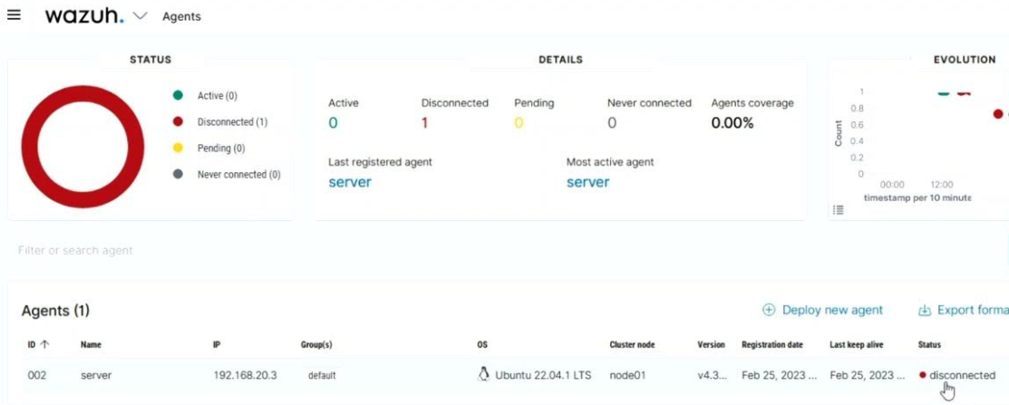
- These are the sample logs.
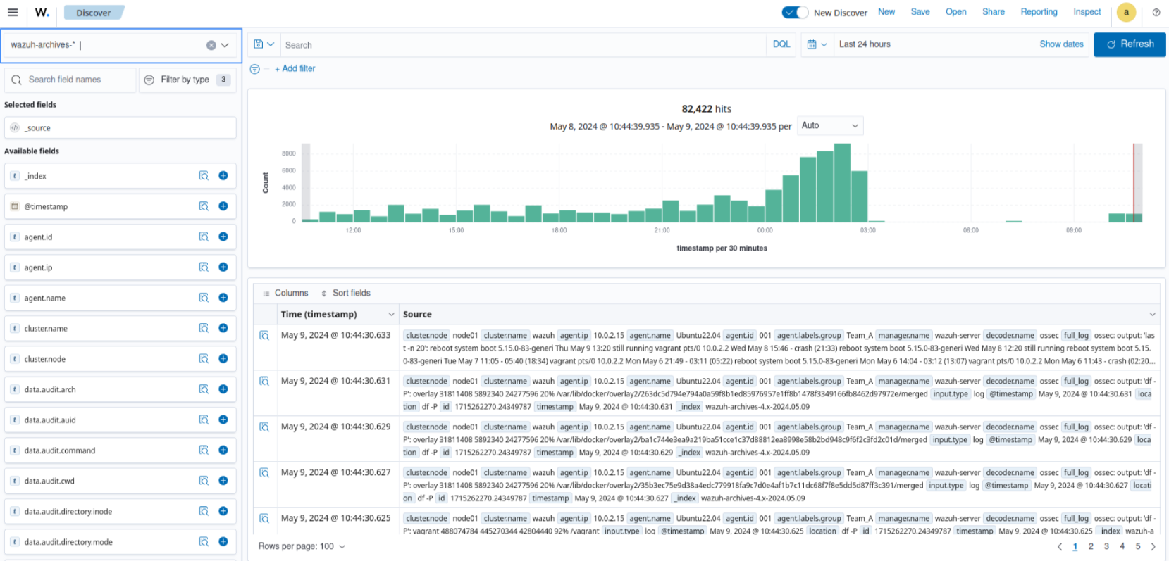
Mitigation:
- Log critical security events with required details
- Enable real-time alerting for abnormal activities
- Protect logs from tampering or unauthorized access
- Regularly review logs and integrate them into a SIEM

Cross-Site Request Forgery (CSRF)
Description: CSRF is a web attack where an attacker tricks a logged-in user into unknowingly performing actions on a website they are already authenticated on, such as changing account details, making purchases, or transferring funds. This happens because the browser automatically sends stored cookies or tokens with every request, even if the request is triggered from a malicious site.
Tool Used: Burp Suite
Platform: SecurityShepherd
Steps:
- Open CSRF lesson from security shepherd. 2. In that lesson we have an input box that accept the message of an image and send it to administrator.
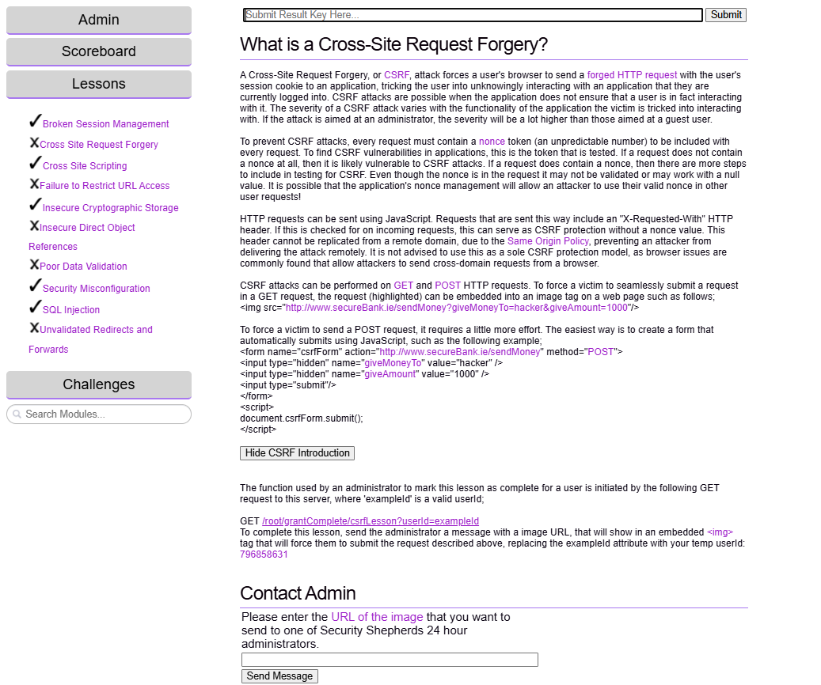
- Now in that box we have pasted the following request in order to pass it to the administrator. https:// 192.168.56.102/index.jsp/root/grantComplete/csrfLesson?userId=40555640. We will get a key and that we have to paste for completion of the lab.
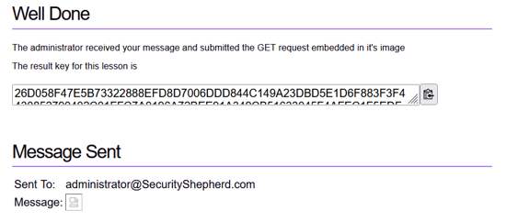
Mitigation:
- Use CSRF tokens for all state-changing requests
- Enable Same Site cookies to limit cross-site requests
- Require re-authentication for sensitive actions
- Block unsafe HTTP methods from untrusted origins

File Inclusion
Description: File Inclusion is a vulnerability where an application loads files based on user input without proper validation. Attackers exploit this by tricking the system into including unauthorized files, either from the local server (LFI: Local File Inclusion) or from external sources (RFI: Remote File Inclusion). This can expose sensitive information, reveal server configurations, or even allow execution of malicious code. In simple terms, file inclusion happens when the application trusts user-supplied paths and ends up pulling files it should never access.
Tool Used: Burp Suite
Platform: DVWA
Steps:
- Go to file inclusion lab in DVWA. In that click any one URL for the file.
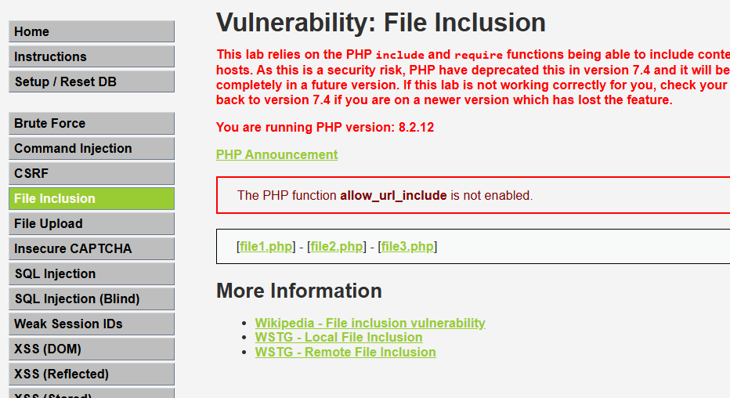
- Now we have changed the page parameter to see the file that is not in the same directory as the website but in another directory but it gives the content of that file also so it leads to an exposure of unwanted files and folders to the users.
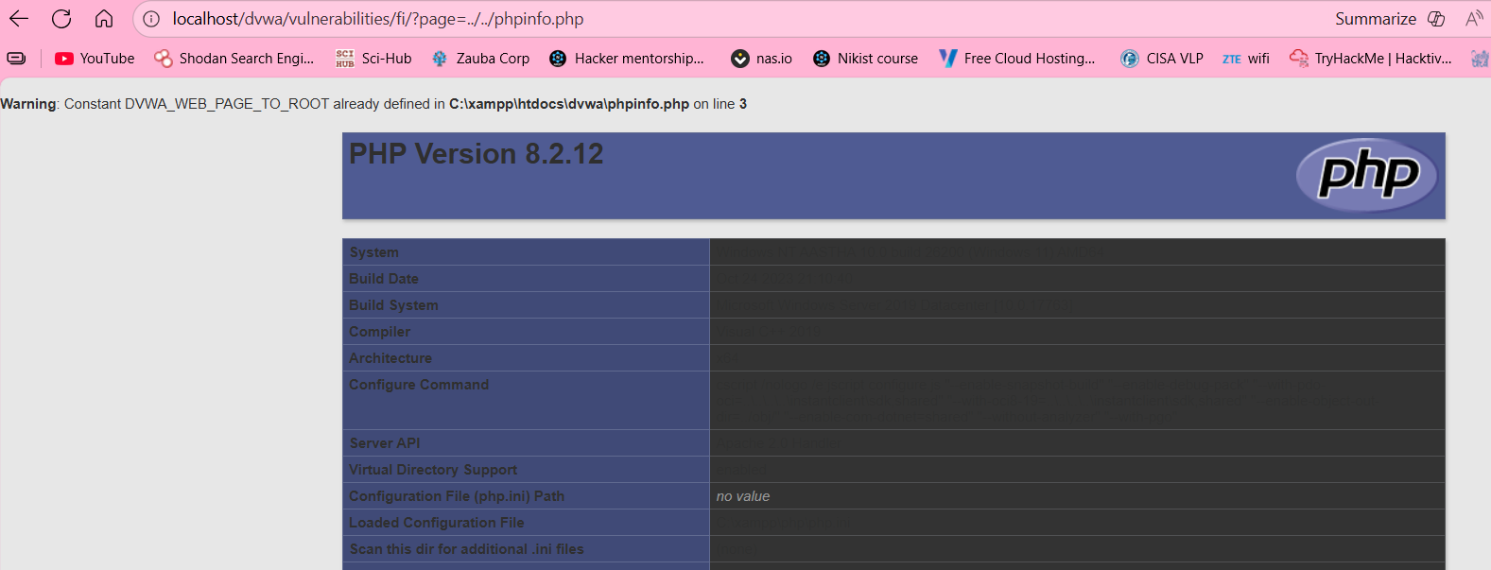
Mitigation:
- Strictly validate and whitelist allowed file paths
- Disable remote file inclusion features in server configs
- Use fixed, hardcoded file paths wherever possible
- Sanitize user input to block traversal patterns like ../

Clickjacking
Description: Clickjacking is an attack where a user is tricked into clicking on something different from what they see on the screen. Attackers usually overlay invisible frames or disguised elements on top of a legitimate webpage. When the victim clicks, they unknowingly perform actions such as changing account settings, liking a malicious page, or confirming transactions.
Tool Used: Burp Suite
Platform: PortSwigger - Basic clickjacking with CSRF token protection
Steps:
- Open PortSwigger lab of basic clickjacking with CSRF token protection and access the lab.
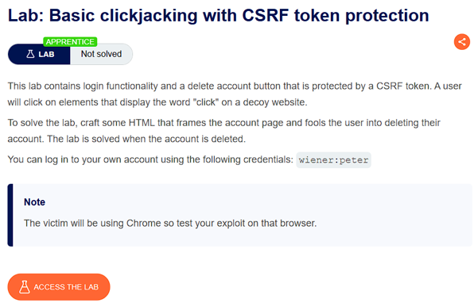
- We have to exploit the clickjacking vulnerability by embedding the victim's authenticated account page inside a hidden <iframe> and overlaying a fake button to trick the victim into clicking the "Delete account" button.
- After accessing the lab we log in to the given blog site with the credentials given along with the lab description(wiener:peter). Now we will create an iframe that overlays the web page and is transparent
- Code
<style>
iframe {
position:relative;
width:500px;
height: 700px;
opacity: $opacity;
z-index: 2;
}
div {
position:absolute;
top:300px;
left:60pxe;
z-index: 1;
}
</style>
<div>Test me</div>
<iframe src="https://Your-Lab-ID.web-security-academy.net/my-account"></iframe>
- Replace “Your-Lab-ID” with the unique lab id generated during the session. And for the opacity value as well as the height and dimension values change as needed. Through trial & error place your button as needed and deliver the exploit.
For testing and Demonstration purposes I have set the opacity value to 0.1.
This allows us to see the iframe slightly without it being transparent.
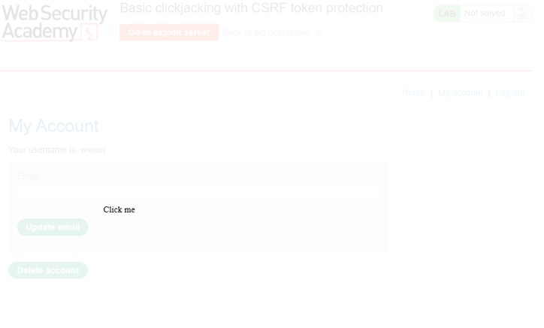
The ‘Click me’ button can now be configured as required to be on top of any button as per the requirement of the attacker to set up a clickjacking attack on unsuspecting users.
Mitigation:
- Use X-Frame-Options (DENY or SAMEORIGIN)
- Implement Content Security Policy frame-ancestors
- Disable framing for sensitive pages
- Use visible click confirmation or re-authentication for critical actions

File Upload Vulnerabilities
Description: File upload vulnerabilities occur when an application allows users to upload files without properly checking their type, content, size, or behavior. Attackers can exploit weak validation by uploading malicious files such as web shells, scripts, or executables. Once uploaded, these files may run on the server, expose sensitive directories, bypass security filters, or manipulate system resources.
Tool Used: N/A
Platform: DVWA
Steps:
- Open file upload vulnerability in DVWA. Make a non-malicious code in html and upload here.
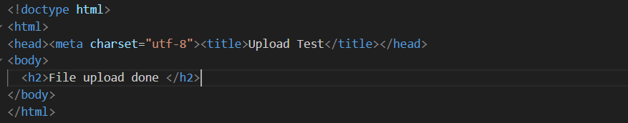
- Once uploaded you will find that it uploads successfully.
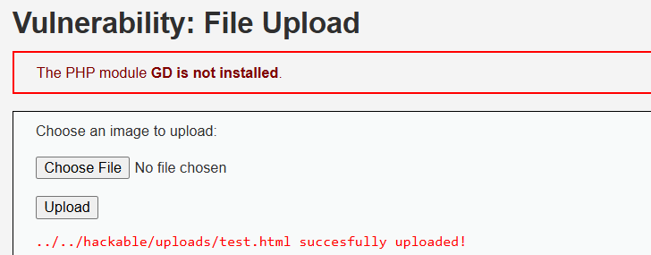
- You will see the result here.
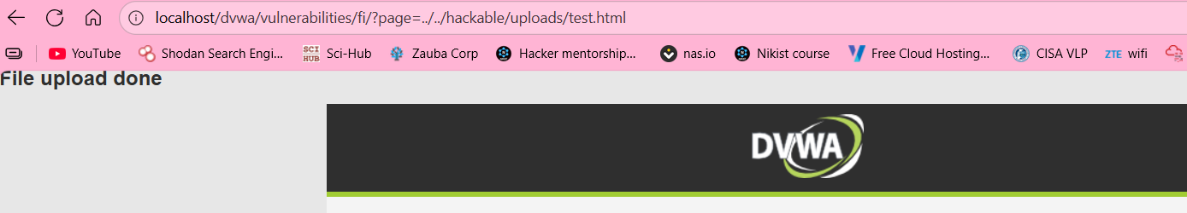
Mitigation:
- Strictly validate file type, size, and content
- Store uploads outside the web-accessible directory
- Rename files and remove executable permissions
- Use antivirus or malware scanning on uploaded files

Server-Side Request Forgery
Description: SSRF is a vulnerability where an attacker tricks a server into making unauthorized requests on its behalf. When an application fetches data from a URL provided by the user, without proper validation, the attacker can supply a malicious address. This forces the server to access internal systems, cloud metadata endpoints, or sensitive network resources that the attacker cannot reach directly.
Tool Used: Burp Suite
Platform: PortSwigger -Basic SSRF against the local server.
Steps:
- Go to SSRF against local server lab in port swigger. Click on access lab and you can see multiple objects. Go to any object and click on view details button.
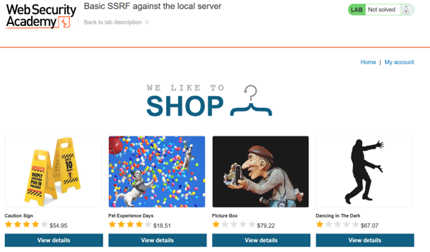
- It will open the detail about that product and at the bottom of that page there is the option to see the stock for that product intercept the request for checking the stock using burpsuite.
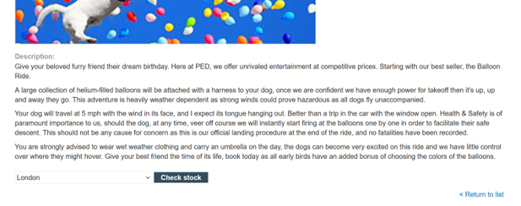
- Now we can see a parameter as an stock Api in that Parmeter we can see some string but we are not able to understand so just select the string and click ctrl+U to unencrypt the string.
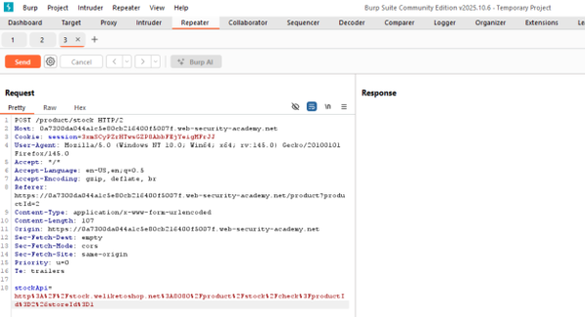
- Change the stock Api to following http request for performing deletion of the user Carlos and press send to send the request.
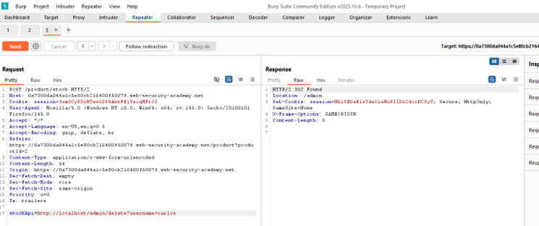
- By this way attacker can perform unwanted task. To complete the lab carlos user was deleted.
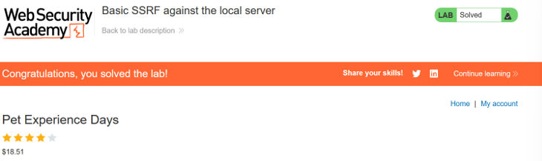
Mitigation:
- Validate and whitelist allowed URLs or domains
- Block access to internal IP ranges (e.g., 127.0.0.1, 169.254.169.254)
- Disable URL redirects and limit protocols (only HTTPS/HTTP)
- Use network-layer controls like firewall rules or VPC restrictions

Insecure Direct Object Reference (IDOR)
Description: IDOR is a vulnerability where an application exposes internal identifiers—like user IDs, file names, or record numbers—directly in URLs or requests without proper access checks. Attackers can simply change these values to access someone else’s data or perform unauthorized actions. This happens because the system trusts the identifier provided by the user instead of verifying whether they are allowed to access that specific resource.
Tool Used: Burp Suite
Platform: Security Shepherd
Steps:
- Open the security shepherd web application and go to insecure direct object references lesson. and click on the refresh your profile to generate the request.
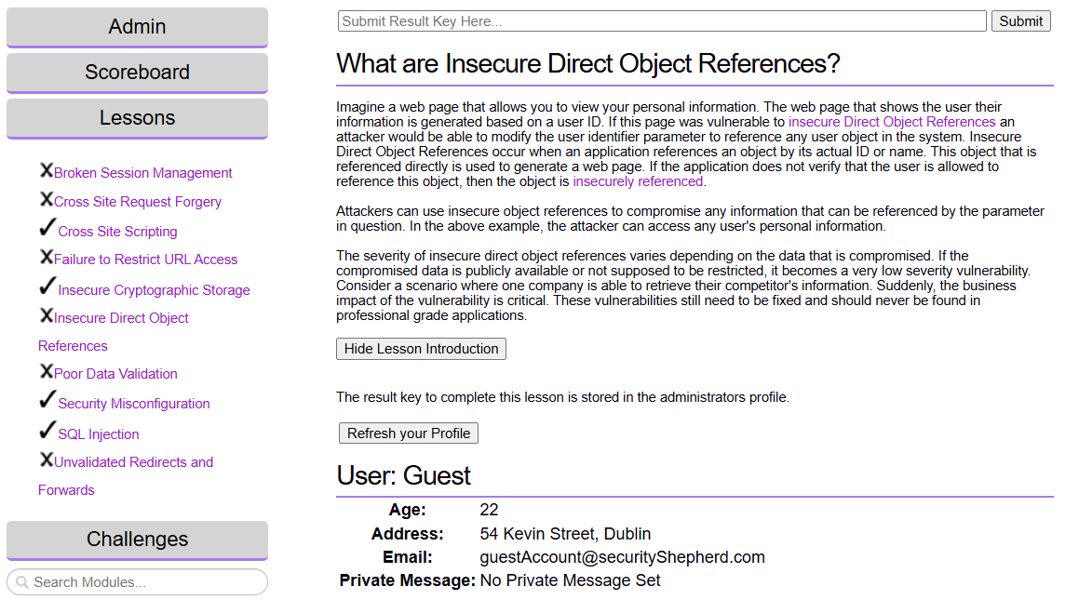
- We have captured the request that loads the user profile and in that we can see a username parameter that is set as a guest.
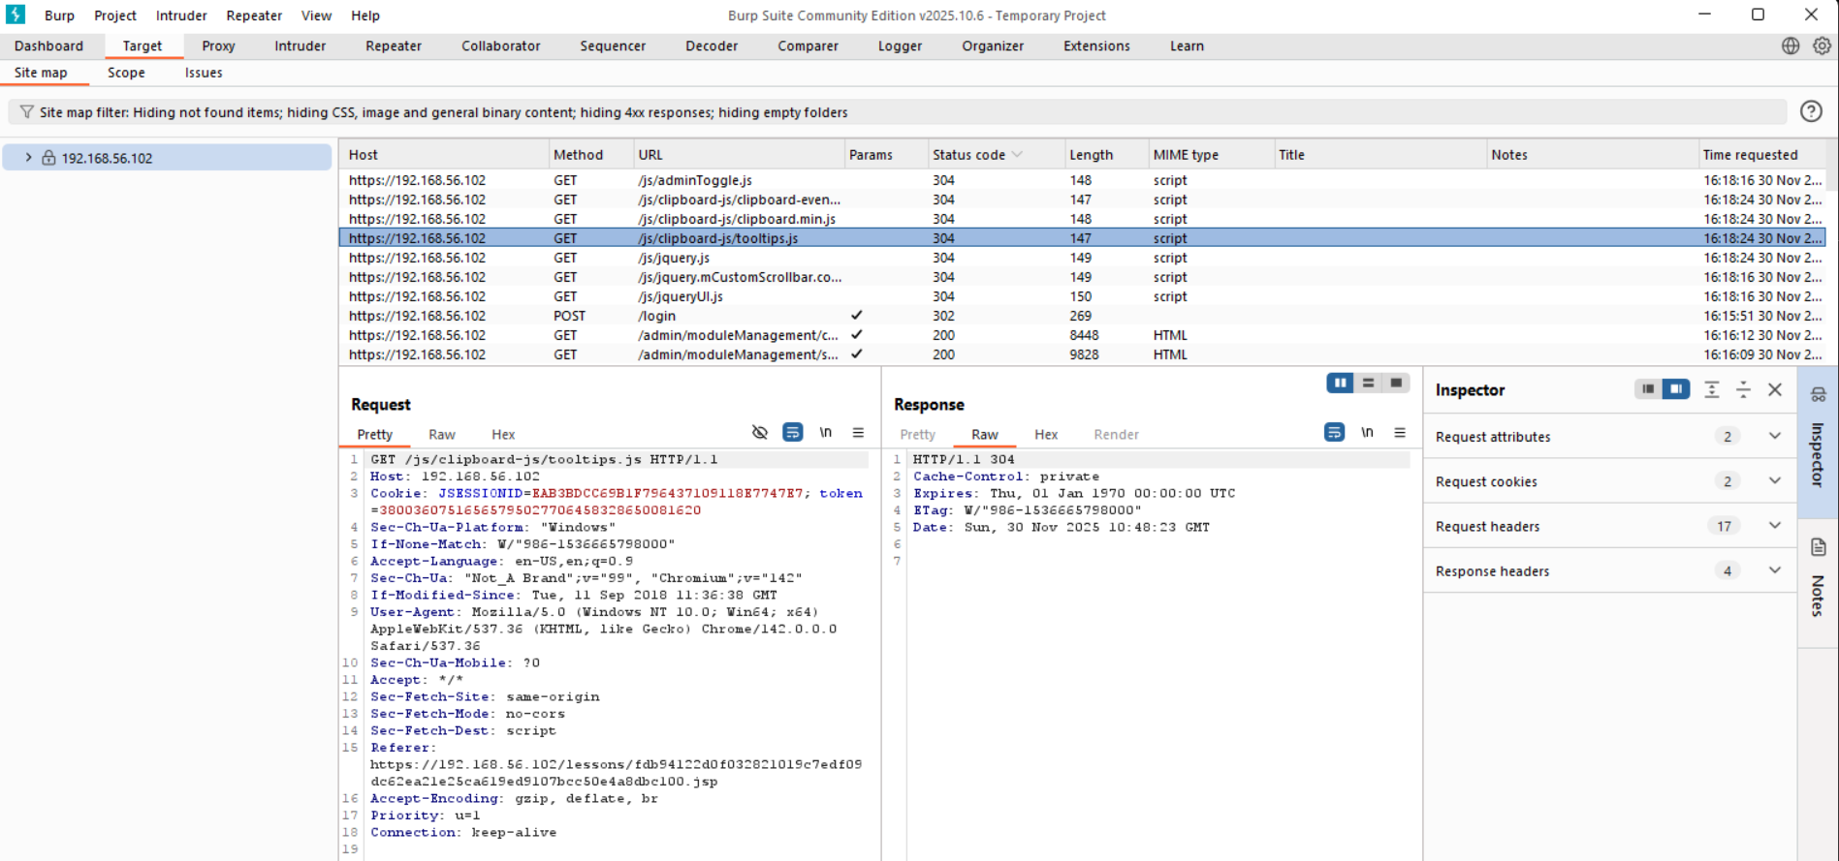
- We can change that username parameter to admin and observe the response of the request by observing the request we have some key.
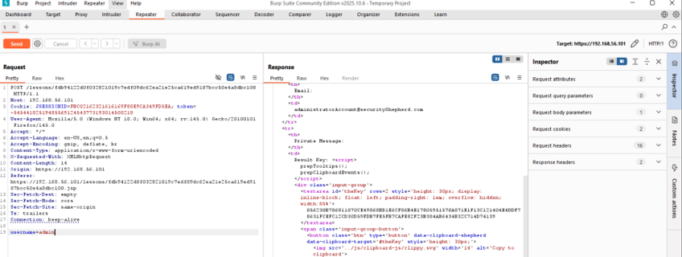
- We have to paste the copied link to the solution box and hit enter in order to complete the attack scenario.
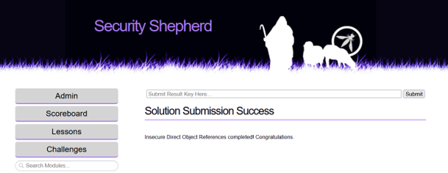
Mitigation:
- Enforce server-side authorization checks for every resource
- Avoid exposing predictable IDs in URLs or API requests
- Use indirect references or mapped tokens instead of raw IDs
- Apply a strict deny-by-default access policy

